1. Activate **PERSONAL** project in Epam Cloud



1. Download maestro-cli

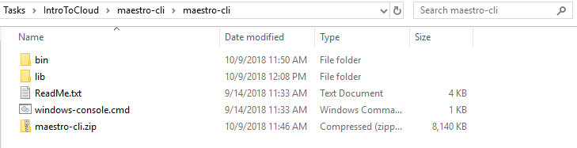

3. Execute describe regions command and choose region to run instance in it

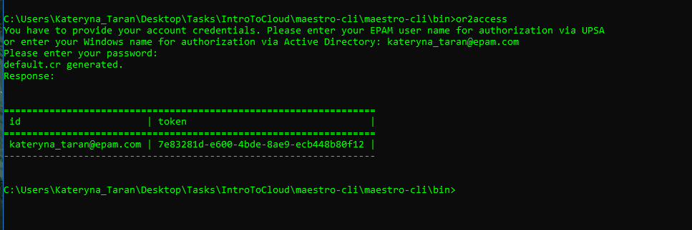

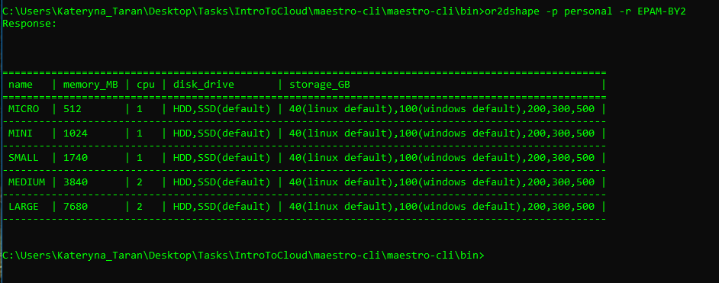

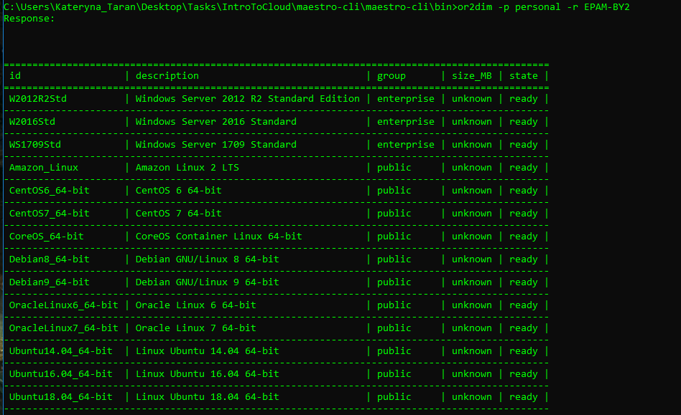

4. Run Linux instance and Windows instances in it

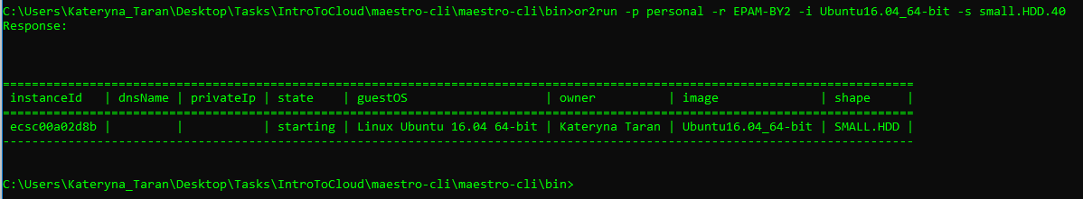

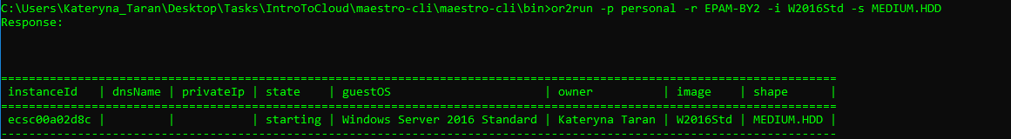

5. Execute describe instance command

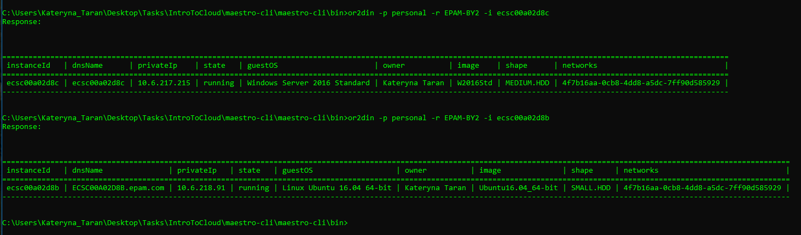

6. Login to Windows instance

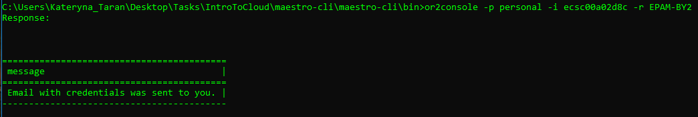

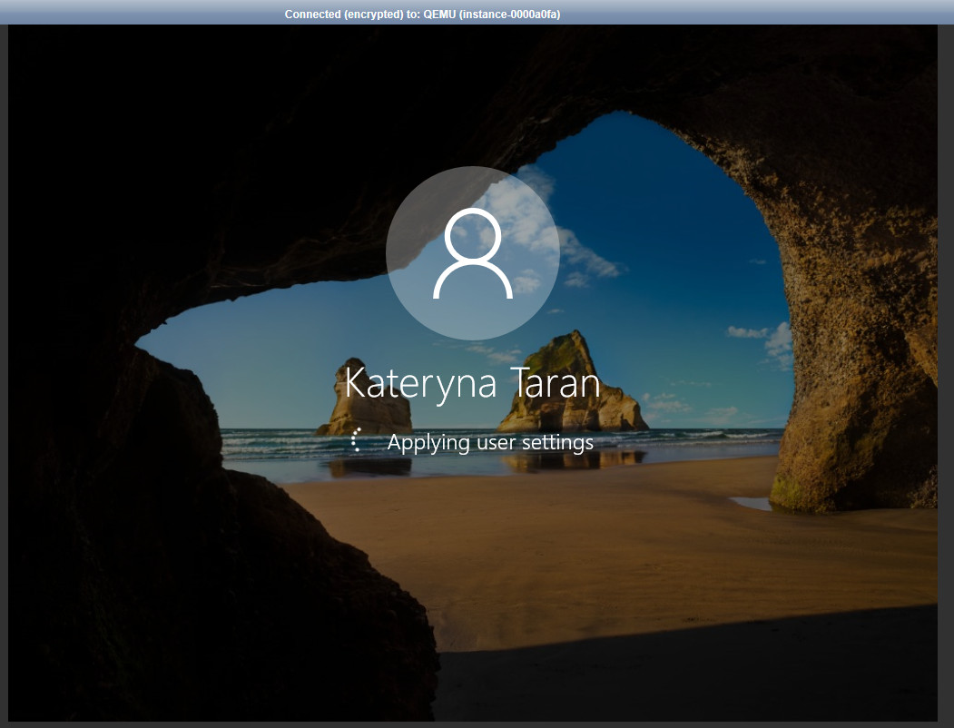

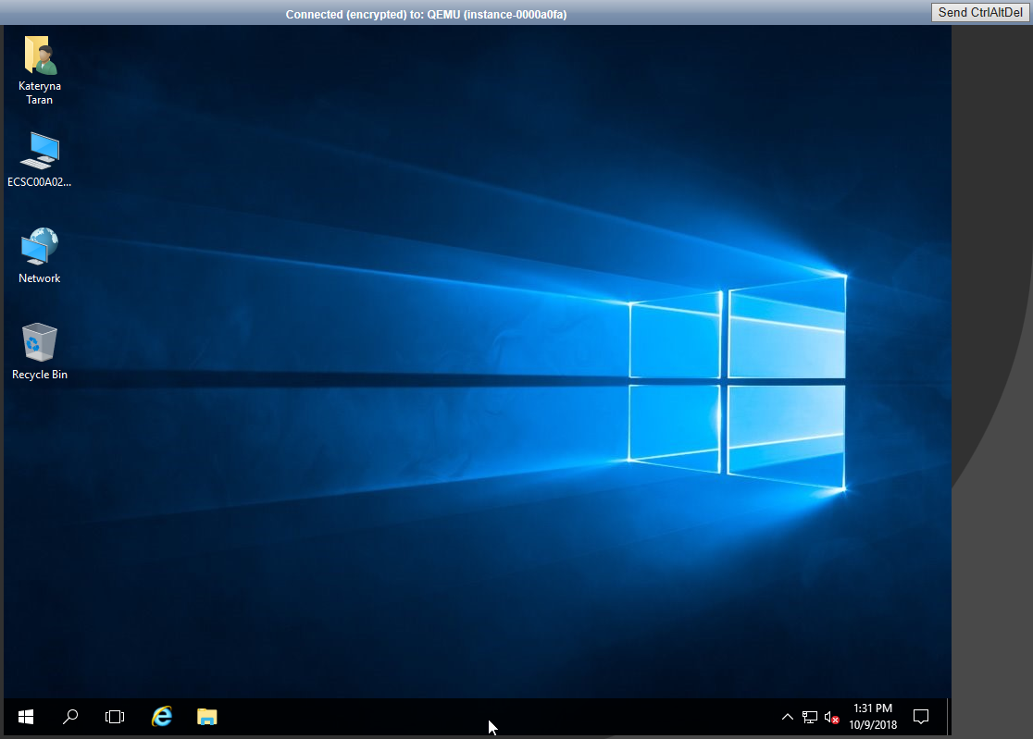

7. Login to Linux instance

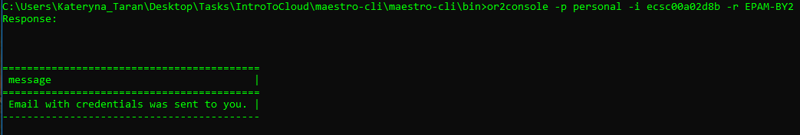

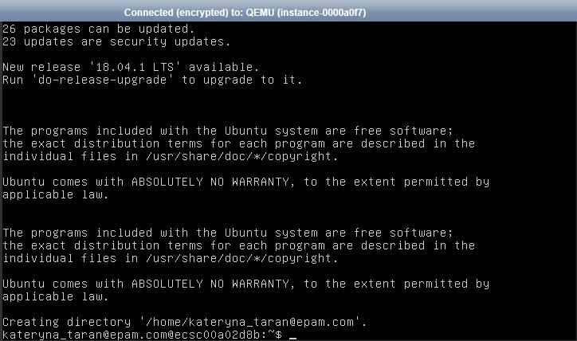

8. Reboot/suspend/stop instance

**WINDOWS:**

Reboot

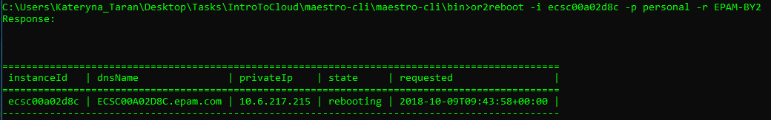

Suspend:



Stop:

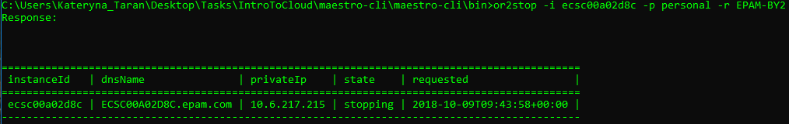

**(UBUNTU)LINUX:**

Reboot:

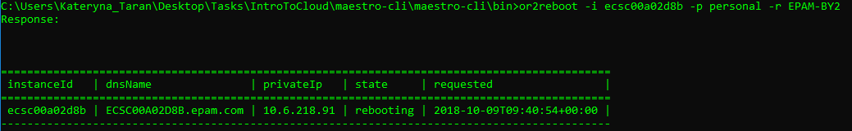

Suspend:



Stop:

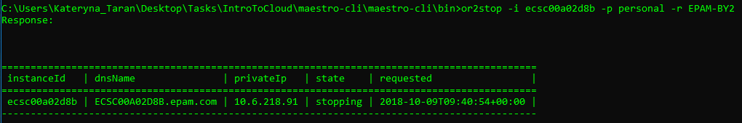

9. Change shape for instance

**UBUNTU(LINUX)**



**WINDOWS**



10. Create and attach volume. Write any information on attached volume (e.g. .doc file, .txt file, .jpg file, create any folder). Attach volume/detach volume

**Create and attach volume, Windows:**

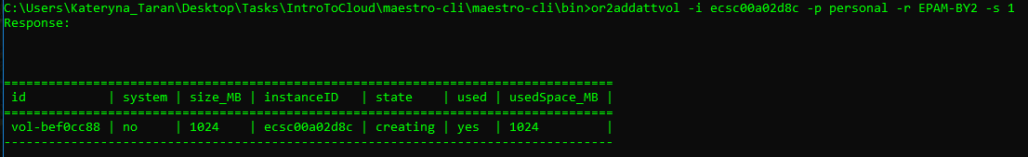

**Create and attach volume, Ubuntu:**

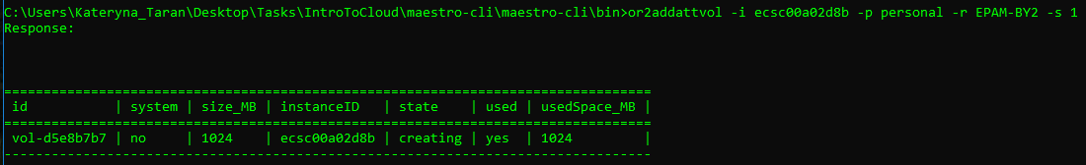

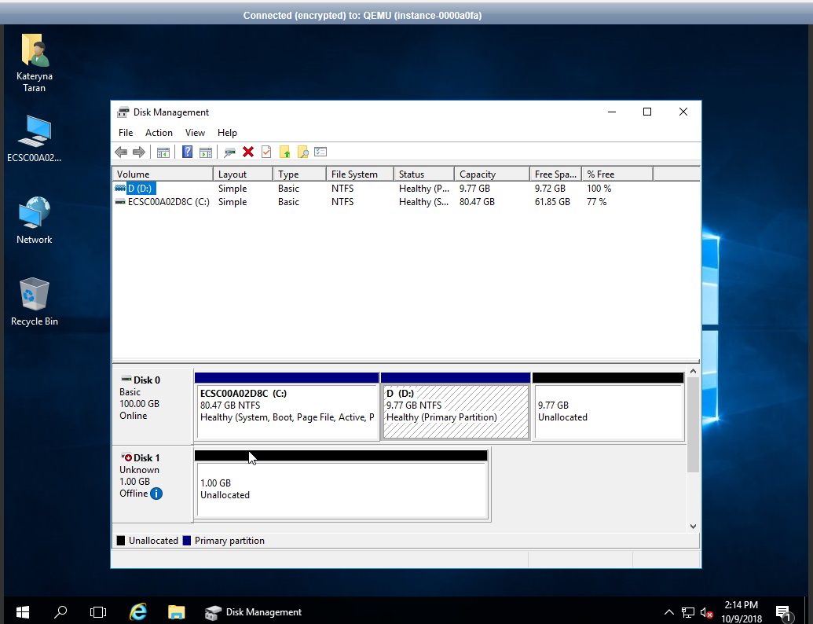

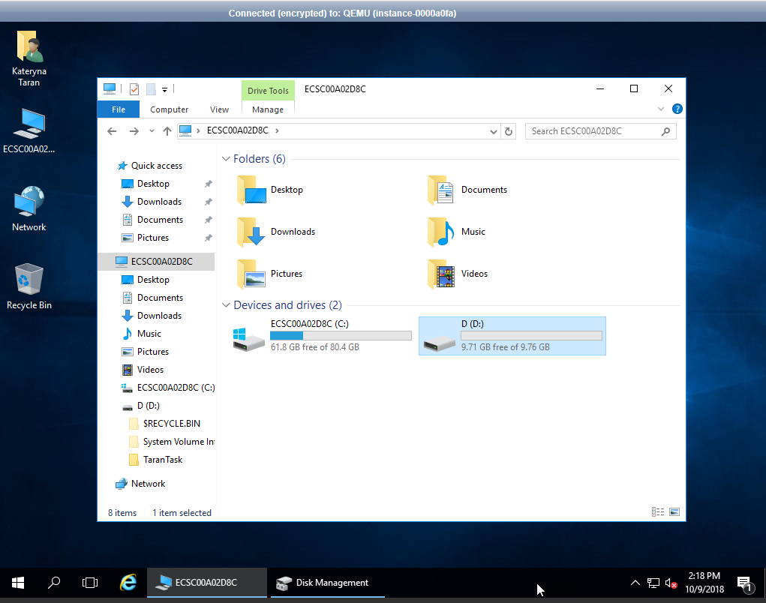

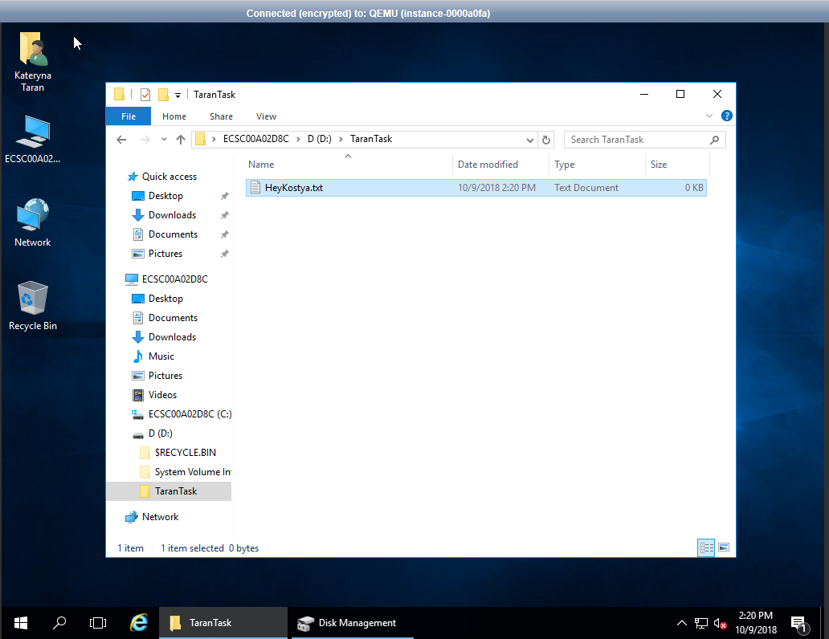

11. Create schedule for instance and check that it works

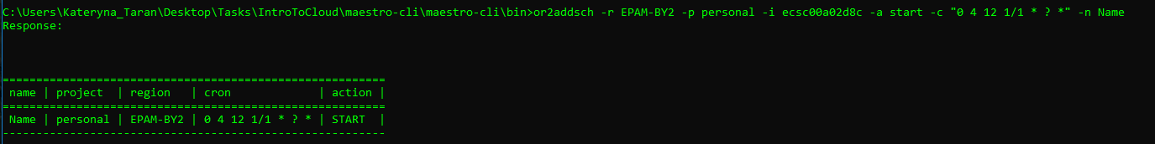

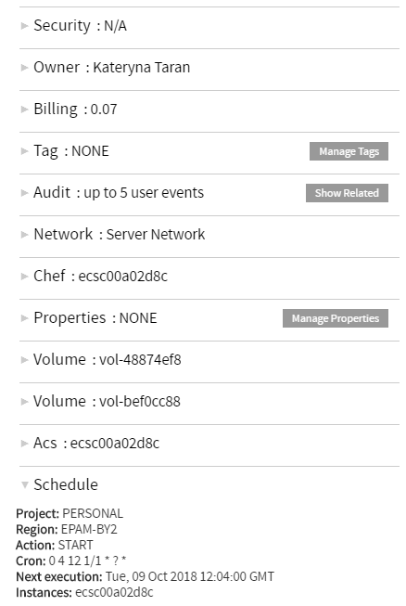

12. Add instance to schedule/remove instance from schedule

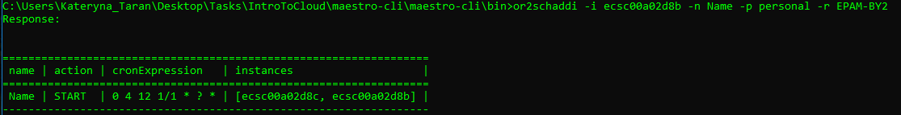

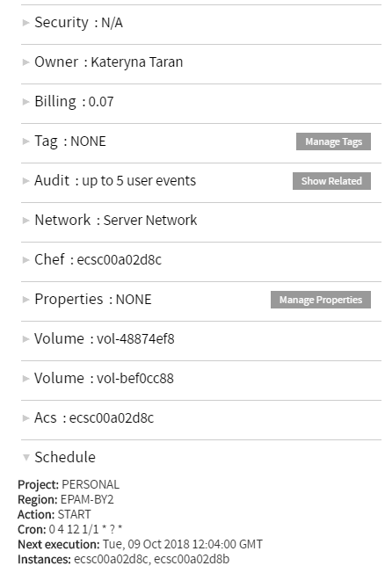

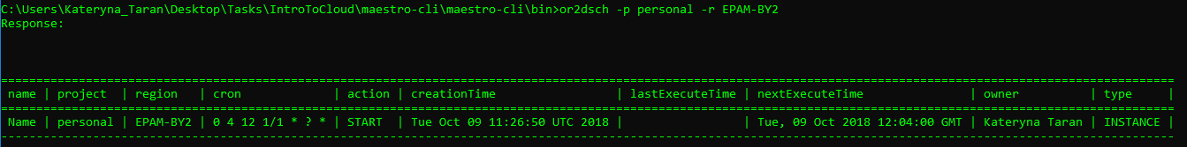

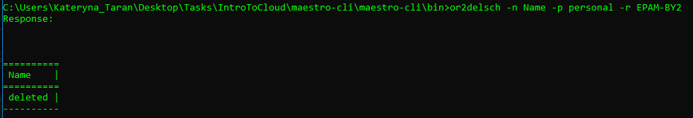

13. Create/describe/delete keypairs

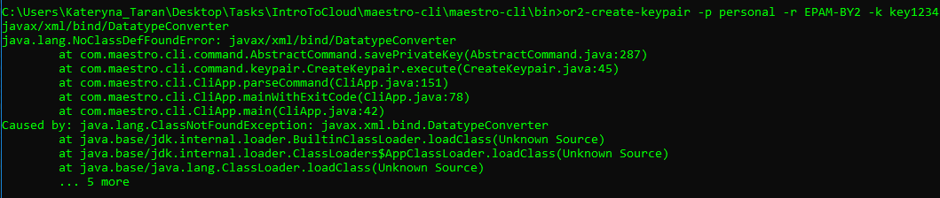

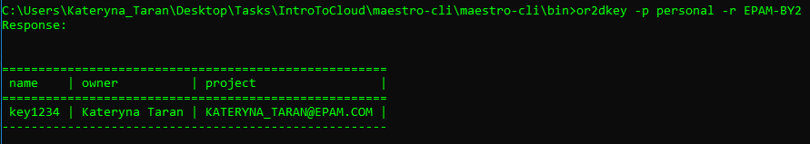

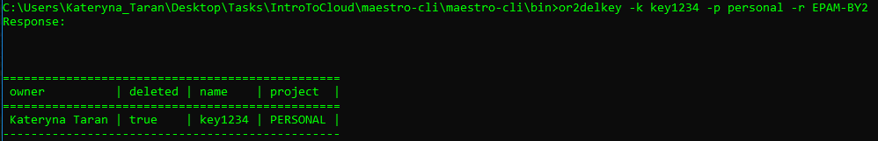

14. Set/describe tag for instance

**WINDOWS:**

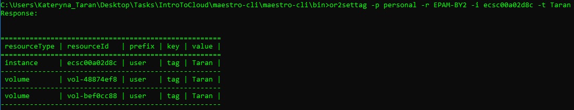

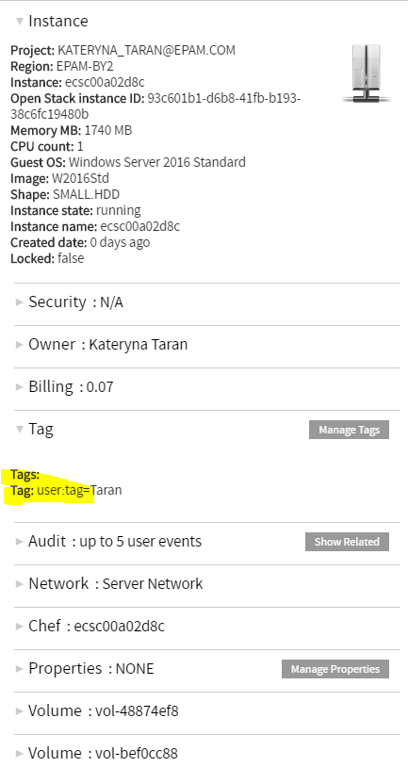

**UBUNTU:**

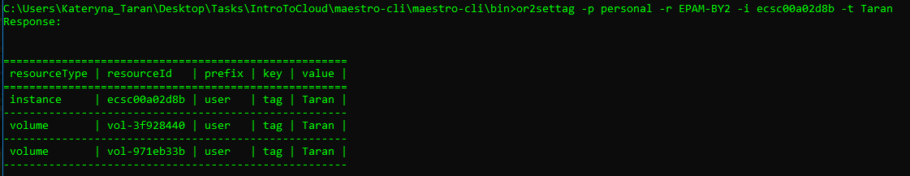

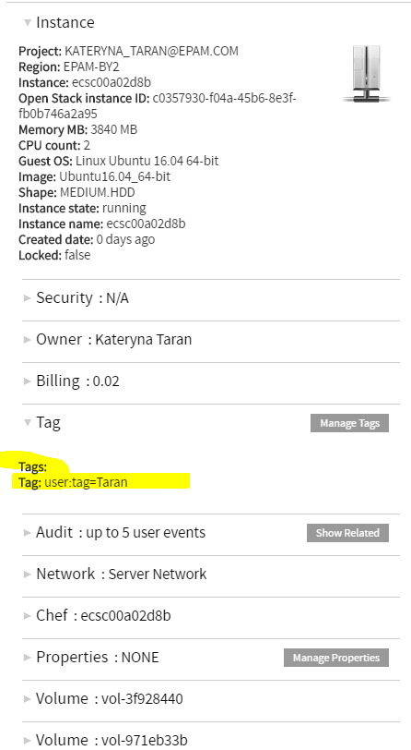

15. Set/describe instance property

**WINDOWS:**

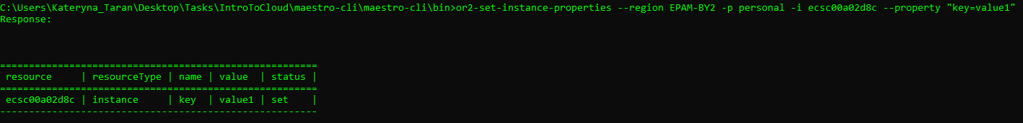

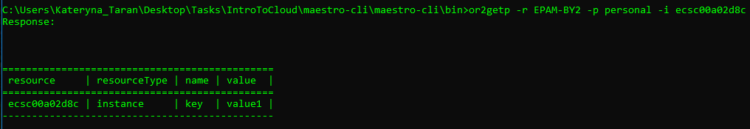

**UBUNTU:**

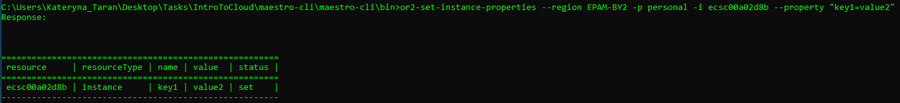

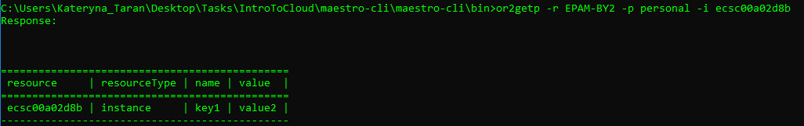

16. Retrieve instance/project audit

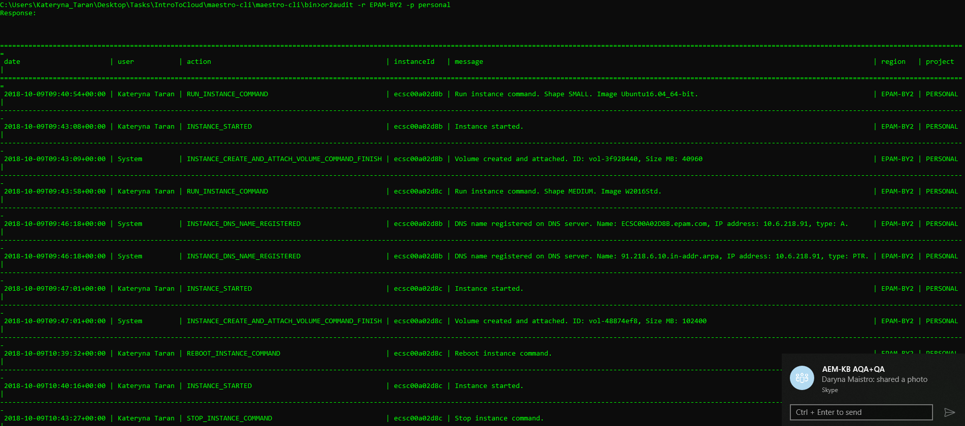

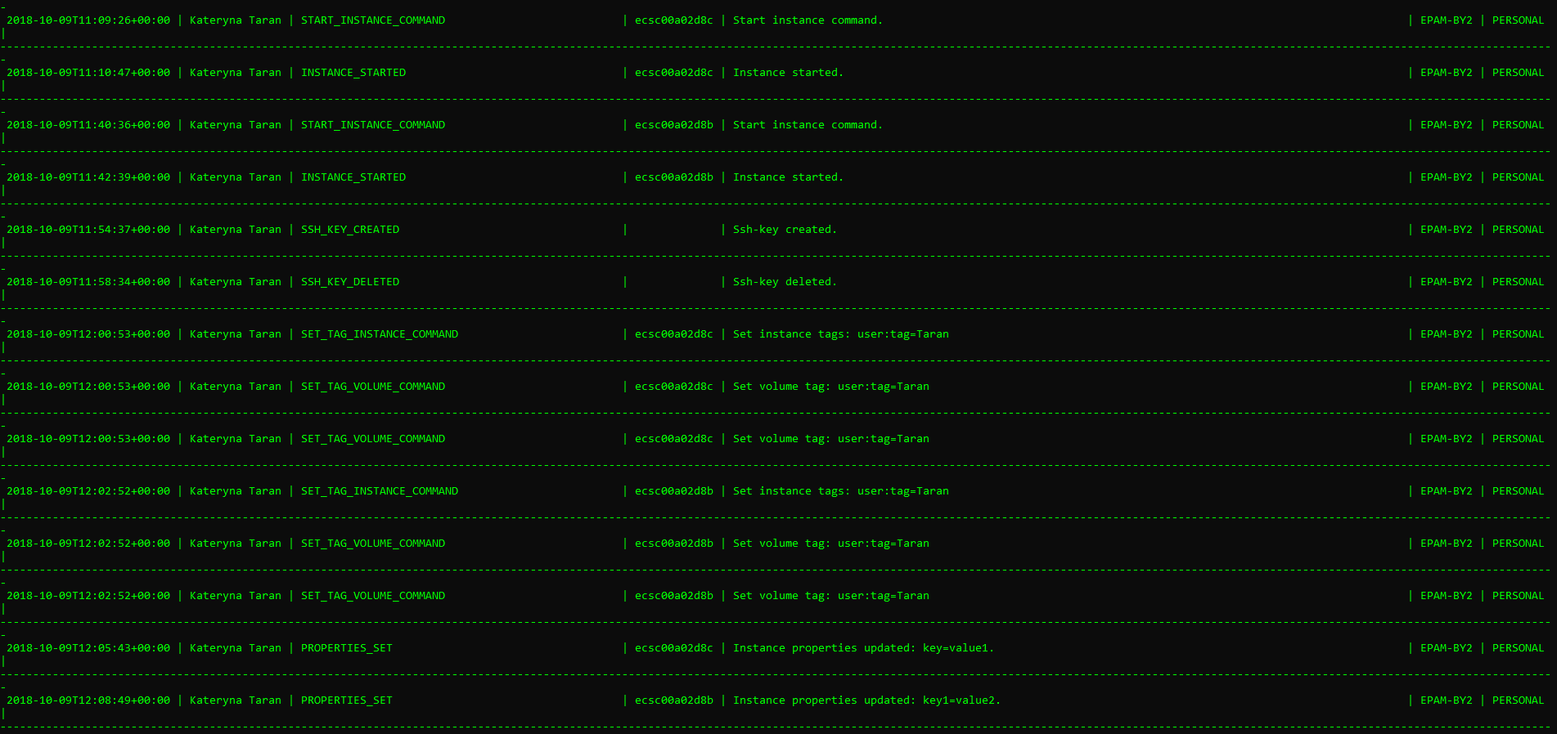

17. Generate different types of utilization report

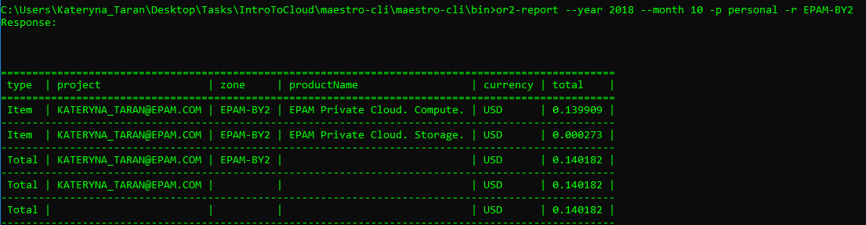

18. Analyze EPAM Cloud changes over the past six months. What of the features you are getting interested that were published to EPAM Cloud during last 6 months?

## Mar - New Features and Improvements

• EPAM-UA1 region decommissioning starts.

• EPAM-RU1 and EPAM-KZ1 regions were completely decommissioned. All projects in these regions were migrated to EPAM-RU2 and other regions.

• The set of the images provided by EPAM Orchestrator was reviewed and updated.

• The Security Guard wizard was introduced.

• The EPAM Cloud Terms and Conditions and EPAM Cloud Security Policy were updated.

**May** - New Features and Improvements

• The Beta version of integration with Exoscale was implemented.

• Logical Volume Manager is removed from all Linux images.

• A set of Azure improvements is introduced: - Managed disks usage is implemented. - Resource Groups management is updated. - Data synchronization is improved. - Security approaches were improved.

## Jul - New Features and Improvements

• The performance in OpenStack regions is improved.

• EPAM-US2 region migrated to the new OpenStack release, Pike.

• EPAM Orchestrator resources migrated to the Ubuntu 18.04.

• AWS Linux 2 image is added to the OpenStack regions image library.

• The monitoring and analytics email reports are upgraded with infographics.

• The CloudWatch service provides resource monitoring in non-AWS regions.

• A set of project management improvements are made:

• - The flow for project activation in Google is improved.

• - The mechanism of new regions activation is updated.

• OpenShift as a Service performance is enhanced with the PTR record creation tool.

• Two new badges are introduced:

• - For passing the Google specializations;

• - For passing Microsoft Azure advanced trainings.

## Sep - New Features and Improvements

• The new billing policy is introduced.

• Performance in EPAM-UA2 and EPAM-US2 regions is improved.

• EPAM-BY2 region is scheduled to migrate to OpenStack Pike.

• Additional resource limitation in personal project is introduced.

• A set of hybrid cloud improvements is introduced:

• - GCP Access is now based on the project role in UPSA;

• - GCP Autoconfiguration has been updated;

• - GCP monitoring process has been improved;

• - AWS Launch Template service is now supported by EPAM Orchestrator.

## 2018

8 Sep

### [**EPAM Cloud Orchestrator version 2.1.130 is released**](https://cloud.epam.com/site/about/announcements/2018/orchestrator_2/1/130_release)

EPAM Orchestrator Framework version 2.1.130 was released on September 8, 2018. The main focus was made on introduction of the new billing policy, aimed to unify the prices across private regions. The main updates on the infrastructure level include legacy infrastructure deprecation, performance improvements, OpenStack updates, and others.

1 Aug

### [**Billing Model Changes in Private Regions**](https://cloud.epam.com/site/about/announcements/2018/pricing_update)

EPAM Cloud has been facing major infrastructure updates during the latest months. These included creating new OpenStack regions and migrating virtual resources to them, updating the OpenStack versions to more recent ones, updating compute hosts and operating systems, and others.

8 Jul

### [**EPAM Cloud Orchestrator version 2.1.125 is released**](https://cloud.epam.com/site/about/announcements/2018/orchestrator_2/1/125_release)

EPAM Orchestrator Framework version 2.1.125 was released on July 8, 2018. The main focus was made on infrastructure changes: the improvements in OpenStack regions performance, EPAM-US2 region migration to the new OpenStack release and migration of EPAM Orchestrator resources to the new operating system. There is also a set of reporting and analytics upgrades, project management updates, the enhancement of OpenShift as a Service and other improvements.

19 May

### [**EPAM Cloud Orchestrator version 2.1.122 is released**](https://cloud.epam.com/site/about/announcements/2018/orchestrator_2/1/122_release)

EPAM Orchestrator Framework version 2.1.122 was released on May 19, 2018. The main focus was made on infrastructure changes: the new public cloud, Exoscale, is now available in beta mode via EPAM Orchestrator. There is also a set of Azure integration improvements, project management updates, a big update in Kubernetes as a Service and other improvements.

24 Mar

### [**EPAM Cloud Orchestrator version 2.1.118 is released**](https://cloud.epam.com/site/about/announcements/2018/orchestrator_2/1/118_release)

EPAM Orchestrator Framework version 2.1.118 was released on March 24, 2018. The main focus was made on infrastructure changes, related to the decommissioning of several regions. There is also a number of changes in security tools and approaches, platform services and auto configuration updates, and other improvements.

28 Jan

### [**EPAM Cloud Orchestrator version 2.1.114 is released**](https://cloud.epam.com/site/about/announcements/2018/orchestrator_2/1/114_release)

EPAM Orchestrator Framework version 2.1.114 was released on January 28, 2018. The main focus was made on infrastructure changes, related to migration to OpenStack and resources usage optimization. There are also changes in security and permissions management processes, platform services updates, and other improvements.

